ITO WORLD Task Bug Report Documents

**Bug ID** : #1111

**Bug Name** : **Product filtering -** The contents after selecting next button is not being filtering for selected product

**Summary** : When we select the next button just below the product list, the incoming page is not filtered as we selected.

**Submit Date** : 11.02.2024

**Reporter** : Sinan Yilmaz – Software Test Automation Engineer

**Platform** : MacOS

**Operation System** : OS X 11.6.5

**Browser** : Chrome 120.0.4896.127

**URL** : https://www.demoblaze.com/index.html

**Step Procedure** : Go to URL https://www.demoblaze.com/index.html

Select any product category

Click on the next button

**Expected Result:** The incoming page should be filtered depending on the category selection.

**Actual Result:** All products displayed on the page have been mixed with products from other categories.

**Screenshot** :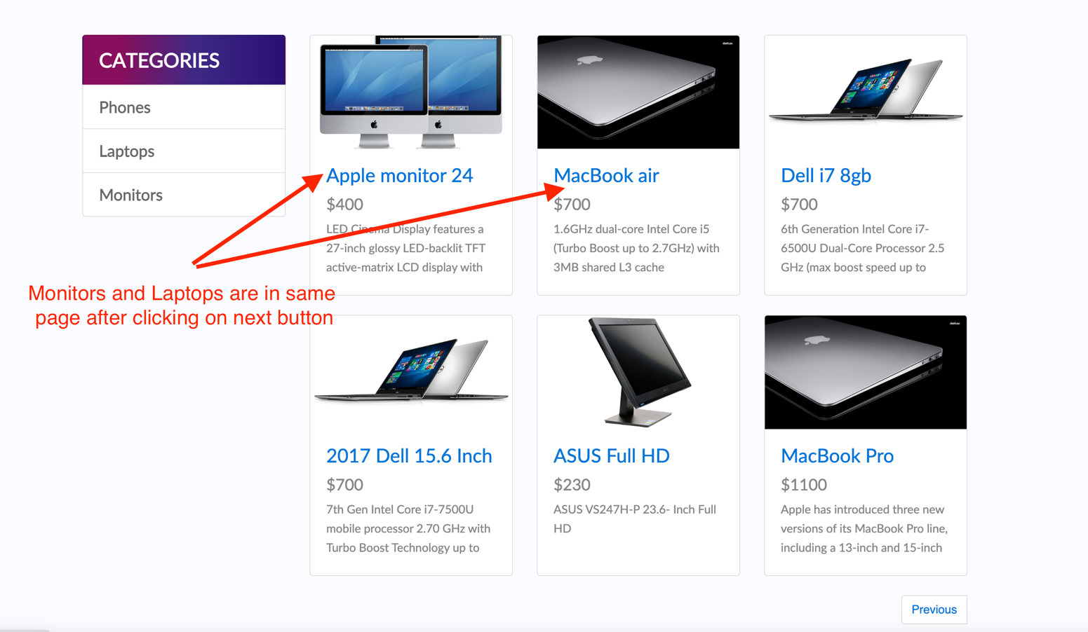

**Bug ID** : #2222

**Bug Name** :Keeping User Credentials – The Sign-up popup is keeping User credentials

**Summary** : After a successful sig up to the page, the sign-up popup is still keeping the credentials as a cache at popup

**Submit Date** : 11.02.2024

**Reporter** : Sinan Yilmaz – Software Test Automation Engineer

**Platform** : MacOS

**Operation System** : OS X 11.6.5

**Browser** : Chrome 120.0.4896.127

**URL** : https://www.demoblaze.com/index.html

**Step Procedure** : Go to URL https://www.demoblaze.com/index.html

Sign up as a new user

Close the successful sign-up alert message

Reselect the sign-up button.

**Expected Result:** Each selection of the Sign-up button should result in an empty form to ensure customer details are kept safe.

**Actual Result:** The popup displays the latest registered user credentials on the form.

**Screenshot** : 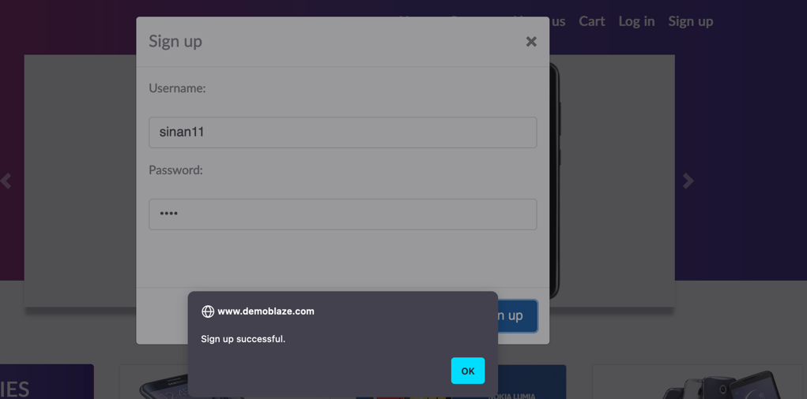

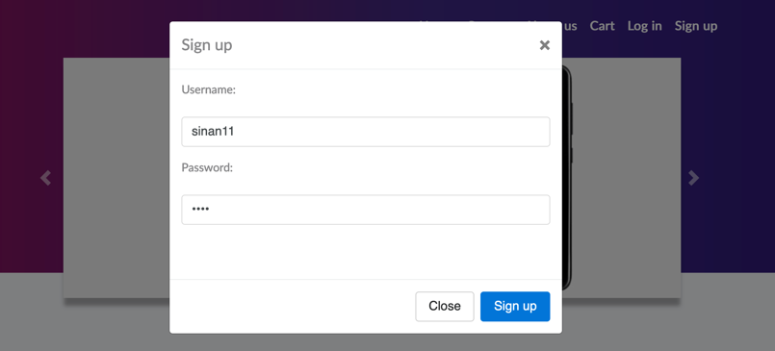

**Bug ID** : #3333

**Bug Name** :Checkout form – The checkout form inputs accept any content indiscriminately.

**Summary** : All inputs are accepting any content indiscriminately even accepting without a content

**Submit Date** : 11.02.2024

**Reporter** : Sinan Yilmaz – Software Test Automation Engineer

**Platform** : MacOS

**Operation System** : OS X 11.6.5

**Browser** : Chrome 120.0.4896.127

**URL** : https://www.demoblaze.com/index.html

**Step Procedure** : Go to URL https://www.demoblaze.com/index.html

Go to checkout form

Write any types of content into related field

**Expected Result** : Checkout form inputs should only accept valid content.

**Actual Result**  : The checkout form inputs accept any content indiscriminately.

**Screenshot** :  
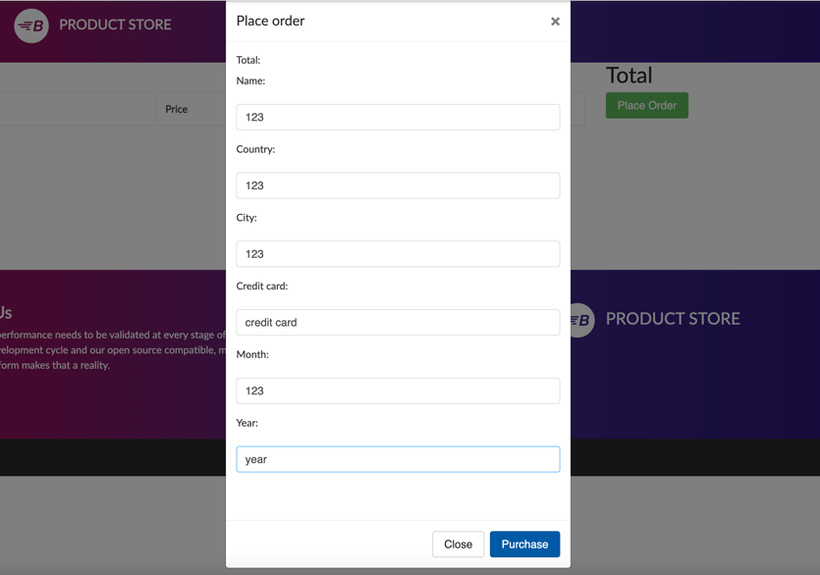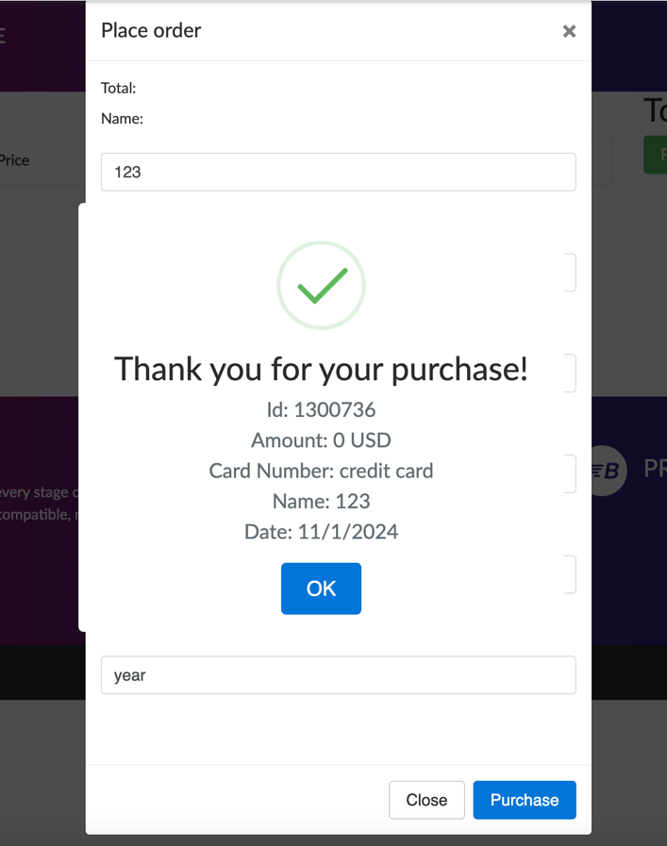

**Bug ID** : #4444

**Bug Name** :CART – Able to checkout without add any product

**Summary** : Without adding any product to the cart, the user is able to checkout and gives order without

any restrictions

**Submit Date** : 11.02.2024

**Reporter** : Sinan Yilmaz - Software Test Automation Engineer

**Platform** : MacOS

**Operation System** : OS X 11.6.5

**Browser** : Chrome 120.0.4896.127

**URL** : https://www.demoblaze.com/index.html

**Step Procedure** : Go to URL https://www.demoblaze.com/index.html

Go to CART by clicking cart icon placed on top of the website.

Pursue the procedure to finish order.

**Expected Result** : The website should create some restriction if anybody try to checkout without adding product

**Actual Result** : The user is able to checkout without facing any restrictions and gives order

**Screenshot** : 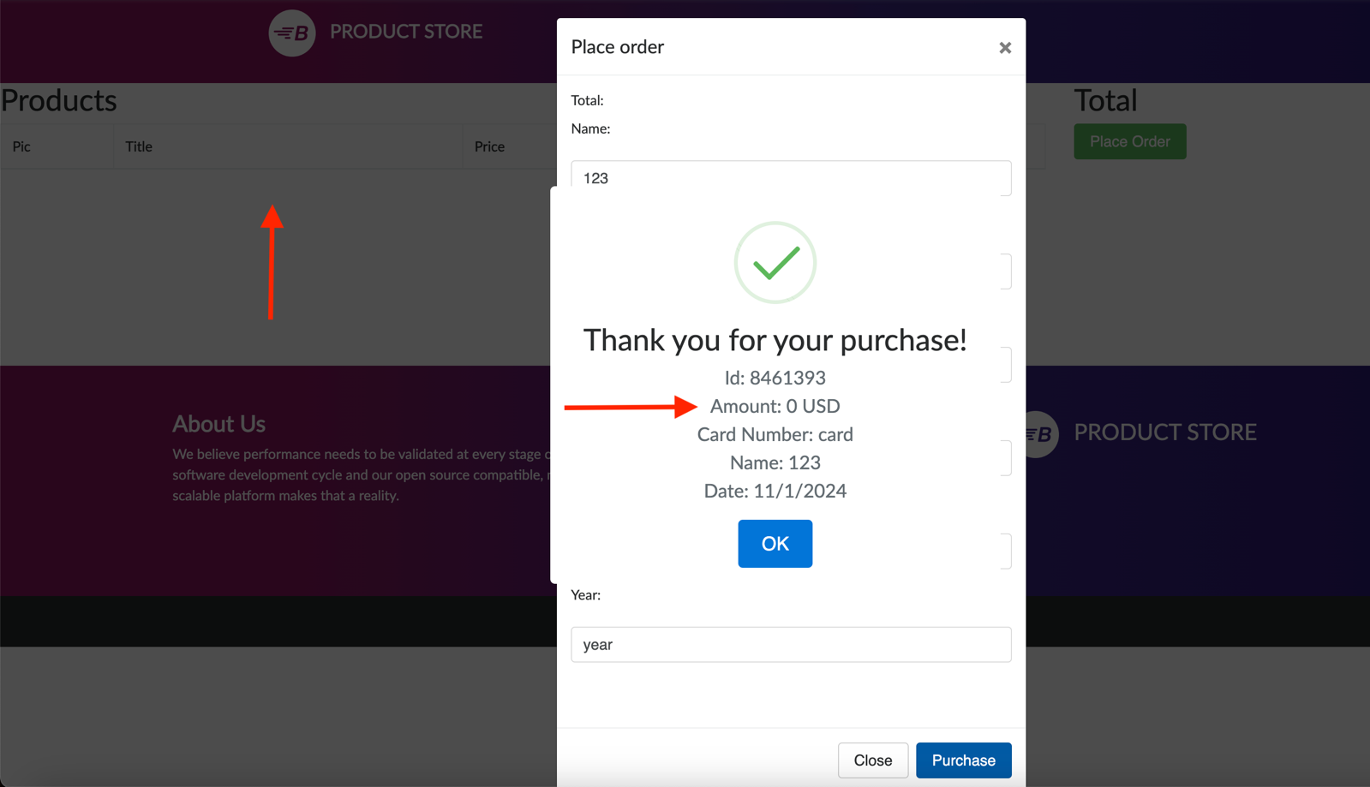

**Bug ID** : #5555

**Bug Name** :DOM – Different Web Element have same id

**Summary** : The sibling web element have same id value, but id should be unique for each indivisual web element

**Submit Date** : 11.02.2024

**Reporter** : Sinan Yilmaz - Software Test Automation Engineer

**Platform** : MacOS

**Operation System** : OS X 11.6.5

**Browser** : Chrome 120.0.4896.127

**URL** : https://www.demoblaze.com/index.html

**Step Procedure** : Go to URL https://www.demoblaze.com/index.html

Inspect the categories at home page

Check the id’s of three categories

**Expected Result:** The ID value should be unique for each web element during implementation.   
**Actual Result:** The ID value for web elements is not unique, leading to potential issues during implementation.

**Screenshot** : 